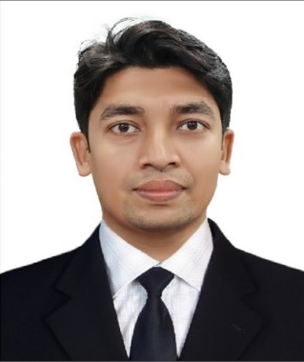

**ACADEMICS**

* **MBA** | Lovely Professional University, Punjab | 2021-23
* **12TH** | Town higher secondary, Tamil Nadu (State board) | 2013-15 | Percentage: 80%
* **10TH** | | Town higher secondary, Tamil Nadu (State board) | 2012-13 | CGPA: 97%

**WORK EXPERIENCE**

* **System analyst | TCS | Aug 2018- Aug 2021(3 years)**
* Have experience in front end and backend applications.
* Good knowledge in all phases of software Testing Life Cycle (STLC) and (SDLC)
* Worked in multiple projects under various teams.
* Good understanding and following agile development process, attending scrum calls, review calls and retrospective meetings.
* Worked as a team member in projects that increased the revenue of the organization and our client.
* SQL Automation to check / validate the list of rules and report the metrics as required.
* Developed windows applications and web applications
* Having experience in testing and web application
* Good experience in demonstrating our user stories and explaining its functionality to clients.
* Having knowledge in Selenium Web Driver

**CERTIFICATIONS**

* **MS Excel | Linked in learning | March 2020**Completed an advanced MS Excel program in linked in learning
* **Agile | Udemy | July 2021**Completed a course named Agile way of working foundation.

**EXTRA CURRICULAR ACTIVITIES**

* **Events**
* Organised an event in ‘Theta’ a cultural competition in SASTRA University.
* Participated in debate competitions in Televisions

**SHRINIVETHIKA Bala**

Shrini.bala1997@gmail.com | +91-8903040813

PROFESSIONAL SUMMARY

To seek an opportunity for professional growth and to be a part of an organization which uses my knowledge, skills for its growth, while giving me opportunities to learn and enrich my knowledge in diverse fields, so that I can fare well in the competitive society.

KEY SKILLS

Human Resource | MS Excel | Marketing

KEY POSITIONS HELD

Coordinator| Ecell club, LPU| 2021

ACHIEVEMENTS

2 ‘On the Spot’ award In TCS.

Award for excellence in TCS.

AREAS OF INTEREST  
Reading, Gaming, Music

PERSONAL DETAILS

D.O.B: 14 Dec 1997

Address – 29, Muthukrishna nagar, Kumbakonam, Tamil nadu.

Languages Known- English, Hindi, Tamil

LINKEDIN ID

[www.linkedin.com/in/shrinivethika](http://www.linkedin.com/in/shrinivethika)-balasubramanian